

Institute of Information Technology,
University of Dhaka
Software Requirements Specification and Analysis
Software Project Lab - III [SE-801]
Project Name: RapidEye
Supervised By:
Dr. Ahmedul Kabir,
Associate Professor,
IITDU
Submitted By:
Mohammad Momenuzzaman (BSSE 1227)
Exam Roll: 2323626
___________________
Supervisor’s Signature
Submitted to:
SPL 3 - Committee
Date. 30 January,2025
Letter of Transmittal
26 November, 2024
BSSE 4th Year Exam Committee
Institute of Information Technology
University of Dhaka

Subject: Technical Report Submission for SPL 3
Sir,
I am pleased to submit the technical report for my project, “RapidEye: Smart Video Monitoring and Alert System for Abnormal and High-Speed Events”, as part of our Software Project Lab 3. This report provides an in-depth overview of the project's technical aspects, encompassing its design, implementation, and testing phases.
While I have made every effort to ensure the report is thorough and detailed, I sincerely welcome your feedback and suggestions for further improvement.
Thank you for your time and consideration.

Sincerely yours,
Mohammad Momenuzzaman
Roll: BSSE 1227
Institute of Information Technology
University of Dhaka

________________
Supervisor’s Signature

Acknowledgment
I am deeply grateful to the Institute of Information Technology for granting me the incredible opportunity to work on “RapidEye: Smart Video Monitoring and Alert System for Abnormal and Rapid Events”. I would like to express my heartfelt gratituude to my supervisor, Dr. Ahmedul Kabir, Associate Professor at the Institute of Information Technology, University of Dhaka, for his invaluable guidance in preparing this analysis document, and for his continued support and feedback on my activities related to the project. Finally, I extend my sincere thanks to my classmates, whose constant support and valuable insights have been immensely helpful throughout this process.

Abstract
The document outlines software requirements, specifications, architectural design, and testing of “RapidEye: Smart Video Monitoring and Alert System for Abnormal and High-Speed Events.” This project intends to analyze real-time and prerecorded video footage, identifying rapid or unusual events through ML algorithms. It integrates cutting-edge video processing techniques to detect anomalies, trigger alerts, and provide actionable insights.
The system leverages machine learning and computer vision to process video data, extract key patterns, and highlight significant events. Additionally, it offers user-friendly visualizations and customizable alerts to enhance understanding and usability. This application is deemed necessary for surveillance purposes, emergency response units, and organizations seeking to automate and optimize video monitoring for safety, security, and computational efficiency.

Table of Contents

Table of Contents 4
Motivation 7
1. Introduction 8
1.1 Purpose 8
1.2 Scope 8
1.3 Project Timeline 9
1.4 Purpose of Document 9
2. Project Description 10
2.1. Core Functionalities 10
2.1.1. Normal Requirements 10
2.1.2. Expected Requirements 10
2.1.3. Exciting Requirements 11
2.2. Usage Scenarios 11
2.1.1. Video Input Processing 11
2.2.2. Movement Detection and Analysis 11
2.2.3. Real-Time Alert Generation 12
2.2.4. Event Recording and Review 12
2.2.5. System Configuration 12
2.2.6. Multi-Camera Support 12
3. Scenario-Based Modeling 14
3.1 Use Case Diagram 14
3.1.1 Level 0 15
3.1.2 Level-1 16
3.1.3 Level 1.1 17
3.1.4 Level 1.1.5 18
3.1.5 Level 1.2 19
3.1.6 Level 1.3 20
3.1.7 Level 1.4 21
5. Class Based Modeling 22
5.1 Final List of Classes 22
5.2 Class Card 23
5.2.1 Video 23
5.2.2 Movement 23
5.2.3 Alert 24
5.2.4 Zone 24
5.2.5 Operator 25
5.2.6 Settings 26
6. Software Design Architecture 28
6.1 Architectural Context Diagram 28
6.2 Defining Archetypes 29
6.2.1 Pipe and Filter Architecture 29
6.2.2 Event Driven Architecture 30
6.2.3 Layered Architecture 31
6.3 Refining the Architecture into components 32
6.3.1 Top level Components 32
6.3.2 Instantiation 33
6.4 Mapping Requirements to Software Architecture 34
7. Test Plan 35
7.1 High-Level Testing Goals 35
7.2 Test Cases 36
Conclusion 40
8. Methodology 41
8.1 Core Components 41
8.1.1 Video Processing Module 41
8.1.2 Motion Analysis Module 43
8.1.3 Event Detection Module 44
8.2 Implementation Process 44
8.3 Quality Assurance Framework 44
9. User Interface 46
9.1 Landing Page 46
9.2 Sample Violence Detected 47
9.3 List of Core Functionalities 48
10. Implementation Details 49
10.1 Technologies Used 49
10.1.1 Frontend Technologies 49
10.1.2 Backend Technologies 49
10.2 Component Implementation 49
10.2.1 Video Processing System 49
10.2.2 Event Detection System 50
10.2.3 Alert Generation System 50
10.3 Key Implementation Features 50
10.3.1 Performance Optimization 50
10.3.2 Error Handling and Recovery 51
10.4 Code Organization 51
11. User Manual 52
11.1 Installation 52
11.2 System Requirements 52
11.3 Getting Started 52
11.4 Using RapidEye 54
Conclusion to Project Report 55

List of figures
Figure 1: Use Case Diagram Level 0 18
Figure 2: Use Case Diagram Level 1 19
Figure 3: Use Case Diagram Level 1.1 20
Figure 4: Use Case Diagram Level 1.1.5 21
Figure 5: Use Case Diagram Level 1.2 22
Figure 6: Use Case Diagram Level 1.3 23
Figure 7: Use Case Diagram Level 1.4 24
Figure 8: CRC Diagram 30
Figure 9: Architectural Context Diagram 32
Figure 10: Pipe and Filter Pattern for Video Processing 32
Figure 11: Event-Driven Architecture for Alert Management 33
Figure 12: Layered Architecture 34
Figure 13: Top Level Components 35
Figure 14: Instantiation of components to second level 36
Figure 15: Video Processing Pipeline 45
Figure 16: Motion analysis 46
Figure 17: Validation improvements in Loss and Accuracy 48
Figure 18: Landing Page 49
Figure 19: Sample of violence detected 50
Figure 20: Initial Configuration Screen 56

Motivation
In a world increasingly dependent on surveillance to achieve safety, security, and operational efficiency, the deficiencies of traditional monitoring systems are very conspicuous. It is increasingly difficult to maintain pace with the amount and intricacy of video information by mere observation and antiquated equipment; this leads to poor incident response times, incidents missed, and compromised decision-making.
With RapidEye, we intend to reinvent video monitoring through real-time analysis and the precise detection of abnormal and high-speed events.
This dynamic system goes beyond traditional surveillance, offering enhanced efficiency, scalability, and ease of use. Whether for public safety, industrial operations, or emergency response, RapidEye empowers organizations to act swiftly, decisively, and effectively. It is a bold leap forward in video analytics, reshaping how we monitor, respond to, and manage critical events in an increasingly fast-paced world.

1. Introduction
This chapter provides an overview of the software requirements and specifications for RapidEye. It outlines the purpose, scope, and target audience of the project, offering a clear foundation for development.

1.1 Purpose
The objectives of this document are as follows:
- To provide a detailed outline of the software requirements for RapidEye, a smart video monitoring and alert system for detecting abnormal and rapid events.
- To clearly define functional and non-functional requirements, ensuring a common understanding among all stakeholders.
- To establish a strong foundation for the development process, aligning expectations and enabling effective execution.

1.2 Scope
The scope of RapidEye is as follows:
- The system will support real-time and prerecorded video analysis.
- It will detect and generate alerts for abnormal or rapid events in video footage.
- Users can customize alert parameters and access detailed event logs.
- The application will include data visualization to enhance user understanding.
- Features like user management and data retention will provide a seamless and tailored experience.

1.3 Project Timeline
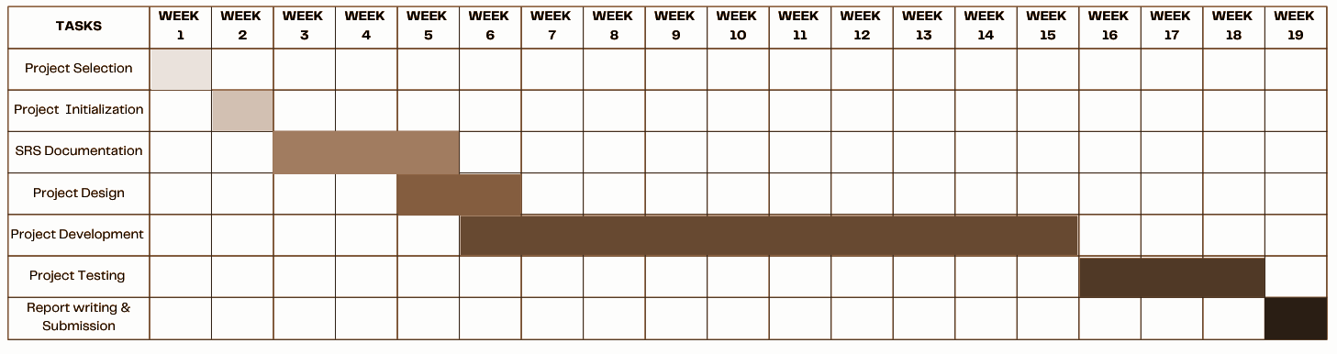
Figure-1: Timeline for RapidEye

1.4 Purpose of Document
The purposes of this document are as follows:
- Identify and analyze the requirements for RapidEye.
- Design the architectural framework for the system.
- Develop a comprehensive test plan to ensure system reliability.
- Outline the methodology for implementing and testing key features.
- Streamline development processes to minimize effort and maximize efficiency.
- Enhance clarity and understanding of the project’s goals and deliverables.

2. Project Description
The following outlines the overview of the core functionalities and objectives of RapidEye. The conceptualization began with a review of surveillance and security systems, particularly focusing on the need for automated threat detection in real-time video streams. The project's scope and requirements were defined through consultations with security professionals and potential end-users, ensuring alignment with practical security monitoring needs.

2.1. Core Functionalities
RapidEye provides an AI-powered solution for real-time detection of suspicious activities and potential threats through video surveillance analysis. The functionalities are grouped into three categories:

2.1.1. Normal Requirements
Video Processing:RapidEye must process video streams (both real-time and recorded) to detect and track human movements.
Movement Analysis: The system must analyze detected movements to identify rapid or suspicious actions using computer vision and pose estimation.
Multiple Person Tracking: The system should accurately track and analyze multiple individuals simultaneously in the video frame.
Alert Generation: Real-time alerts must be generated when suspicious movements or interactions are detected.

2.1.2. Expected Requirements
Detection Accuracy: The AI models should maintain high accuracy in detecting and analyzing human movements.
Performance Optimization: The system must operate efficiently on CPU hardware for widespread deployment capability.
Robust Tracking: The system should maintain accurate tracking even with partial occlusions or challenging angles.

2.1.3. Exciting Requirements
Interaction Analysis: Detection of interactions between multiple individuals and assessment of potential threats.
Event Recording: Automatic recording and storage of detected suspicious events for future reference.
Customizable Sensitivity: Adjustable thresholds for movement detection and alert generation based on deployment context.
Weapon Detection: Future capability to detect weapons and other threatening objects.

2.2. Usage Scenarios
RapidEye functions as a video surveillance system enhanced with AI capabilities for automated threat detection. The usage scenarios are as follows:

2.1.1. Video Input Processing
The system accepts video input from surveillance cameras and processes each frame to detect human presence using object detection.

2.2.2. Movement Detection and Analysis
For each detected person, the system:
- Applies pose estimation using MediaPipe
- Tracks key body points and analyzes movement patterns
- Calculates movement speeds and identifies rapid or suspicious movements
- Detects interactions between multiple individuals

2.2.3. Real-Time Alert Generation
When suspicious activities are detected, the system:
- Generates immediate alerts with relevant details
- Marks the concerning individuals or interactions in the video feed
- Provides movement speed and interaction proximity data

2.2.4. Event Recording and Review
The system maintains a record of detected events, allowing security personnel to:
- Review marked footage of suspicious activities
- Analyze movement patterns and interaction data
- Export relevant clips for documentation or further analysis

2.2.5. System Configuration
Security administrators can:
- Adjust sensitivity thresholds for movement detection
- Configure alert parameters
- Customize detection zones and monitoring priorities
- Manage recording and storage settings

2.2.6. Multi-Camera Support
RapidEye processes feeds from multiple cameras while:
- Maintaining independent analysis for each stream
- Correlating events across different cameras
- Providing a unified interface for monitoring and alerts
This structured approach ensures that RapidEye fulfills its goal of providing an efficient, automated, and reliable system for security monitoring and threat detection.

3. Scenario-Based Modeling
Scenario-based modeling is a method used in software development to create models that represent system behavior under various real-world conditions. For RapidEye, the scenarios focus on user interactions and how the app handles different events, enabling developers to identify potential issues and design solutions effectively.

3.1 Use Case Diagram
A use case diagram is a key visualization tool in software engineering that illustrates how a system interacts with external entities, or actors, to accomplish specific tasks or objectives. It provides a clear representation of the relationships between use cases, which depict the system's functionalities, and actors, which represent external users, devices, or other systems.
Typically created during the requirements gathering phase, a use case diagram helps identify the core functionalities of the system and how users will interact with them. These requirements are then translated into a graphical format using software modeling tools, ensuring a structured and organized view of the system's intended behavior.
By highlighting the connections between users and system functionalities, use case diagrams offer a concise overview of how the system operates, aiding in communication and alignment among stakeholders, designers, and developers.

3.1.1 Level 0
Name: RapidEye Surveillance System
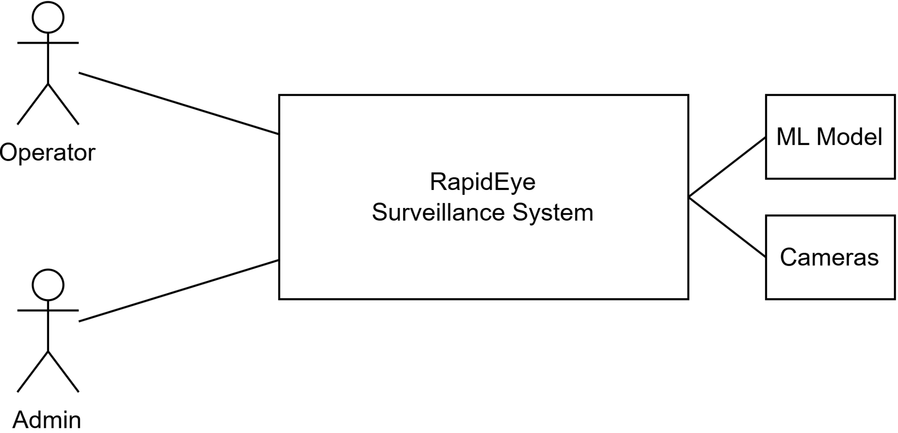

Figure 1: Use Case Diagram Level 0
Primary Actors:
- Operator
- Admin
Secondary Actors:
- ML Model
- Cameras
Both actors interact directly with the core RapidEye system, establishing the highest level view of system interaction.

3.1.2 Level-1
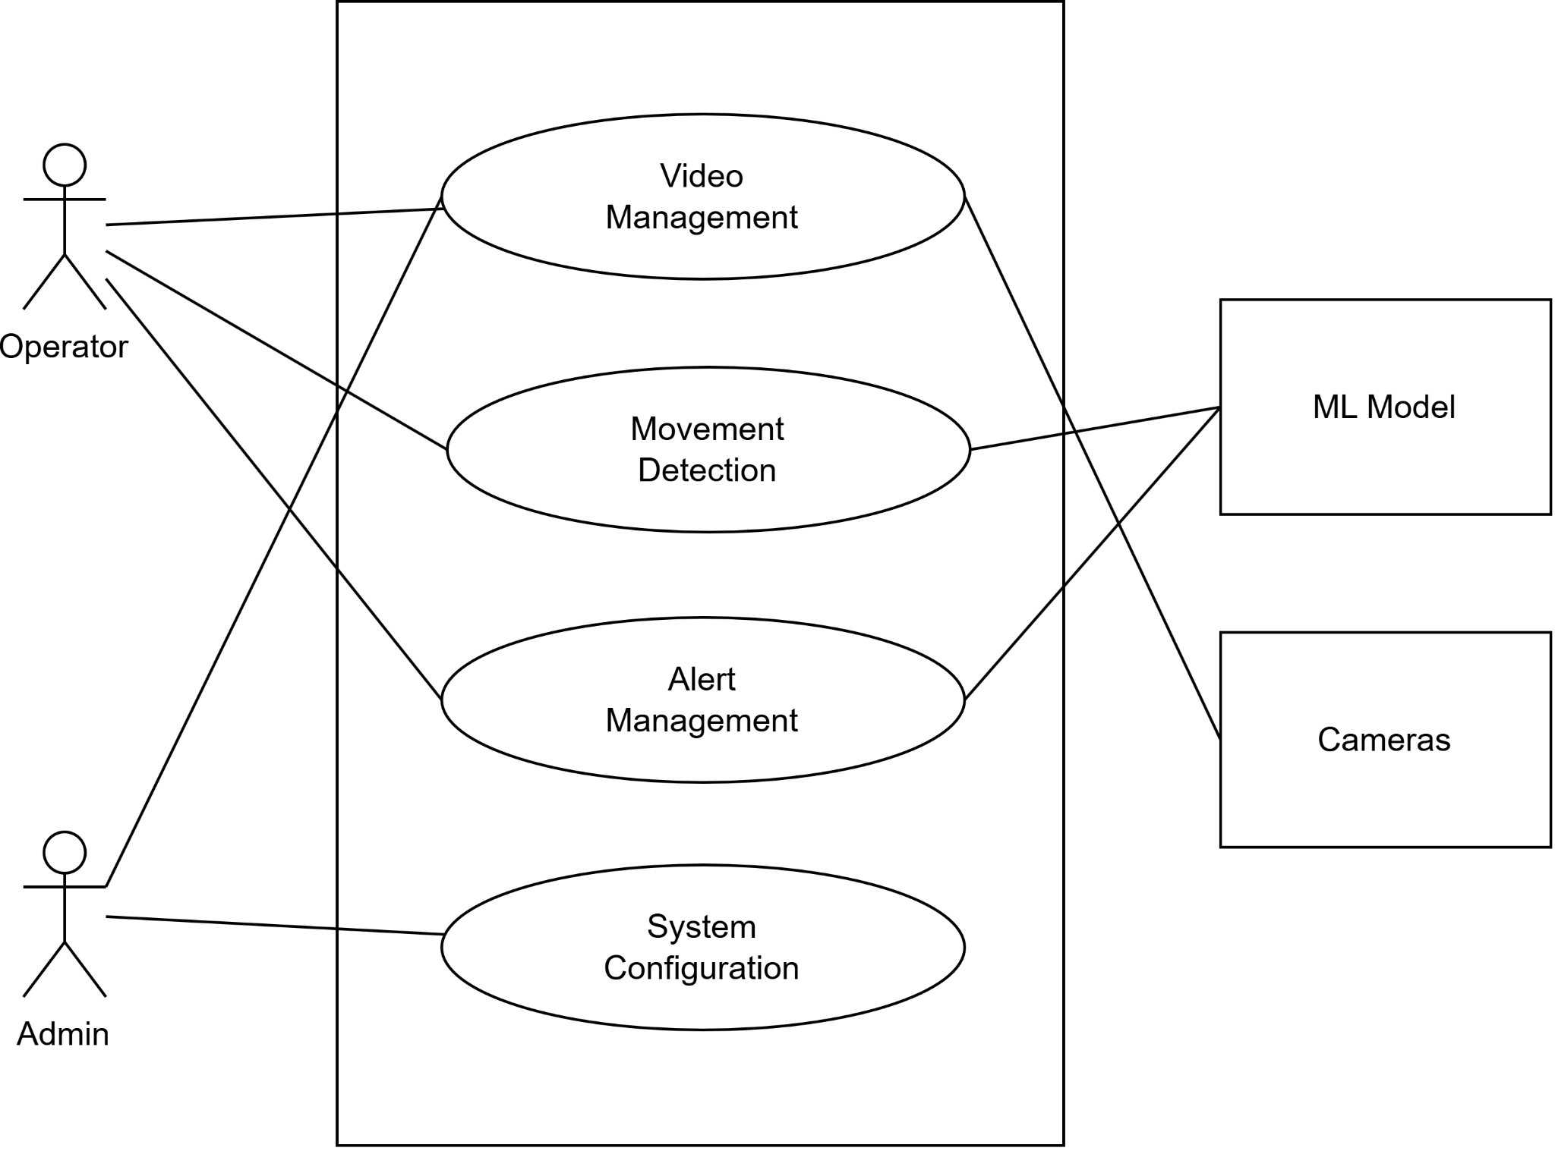
Name: RapidEye System

Figure 2: Use Case Diagram Level 1
Primary Actors:
- Operator (interacts with Video Management, Movement Detection, Alert Management)
- Admin (interacts with System Configuration and Video Management)
Secondary Actors:
- ML Model
- Cameras
Main use cases include:
- Video Management: Control and management of video feeds
- Movement Detection: Detection and analysis of suspicious movements
- Alert Management: Handling system alerts and notifications
- System Configuration: Managing system settings and parameters

3.1.3 Level 1.1
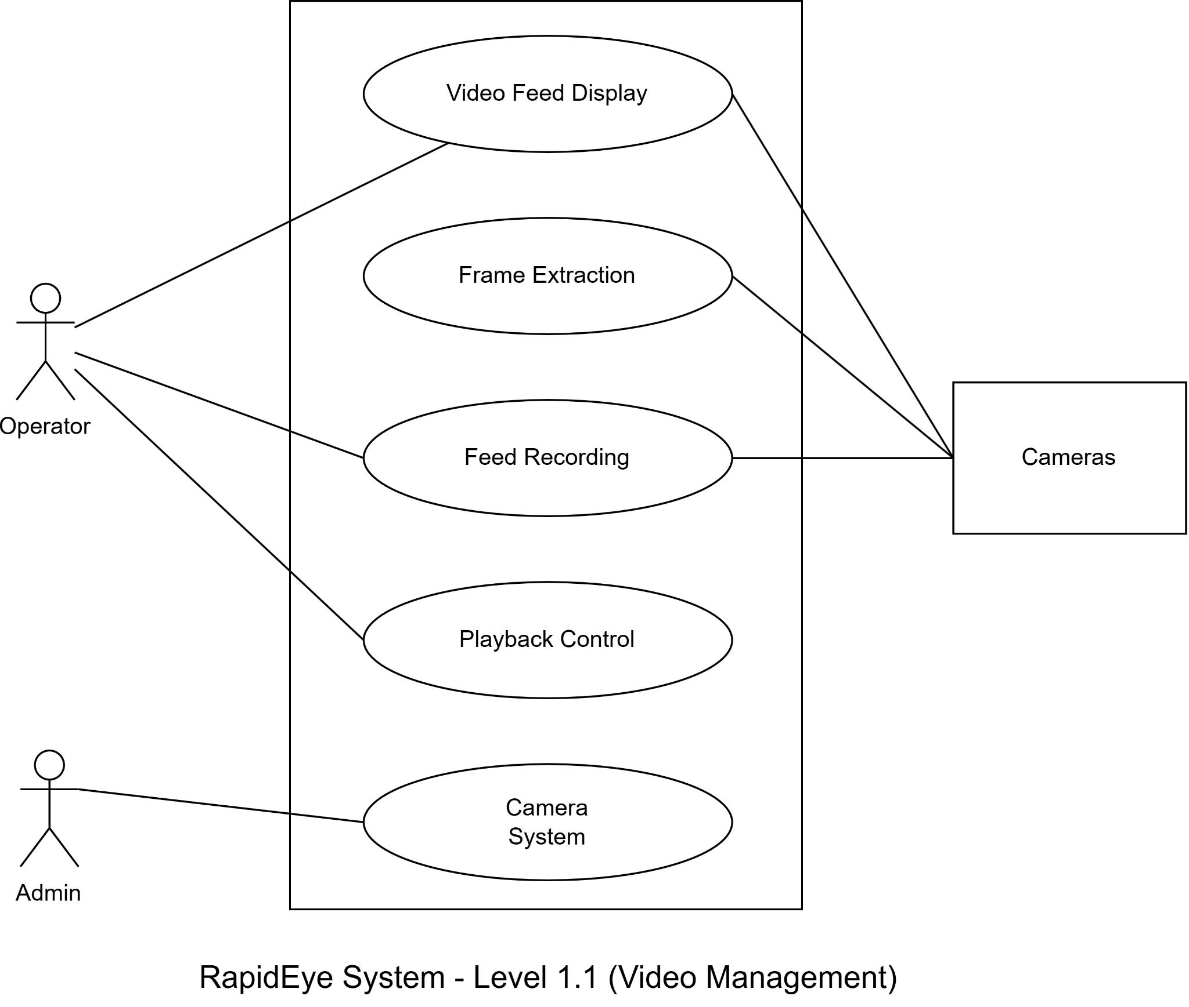
Name: Video Management

Figure 3: Use Case Diagram Level 1.1
Primary Actors:
- Operator (interacts with first 4 use cases)
- Admin (interacts with Camera System)
Secondary Actors: Cameras
Use cases include:
- Video Feed Display: Real-time display of surveillance feeds
- Frame Extraction: Processing video frames for analysis
- Feed Recording: Storing video footage
- Playback Control: Managing recorded video playback
- Camera System: Hardware management and control

3.1.4 Level 1.1.5
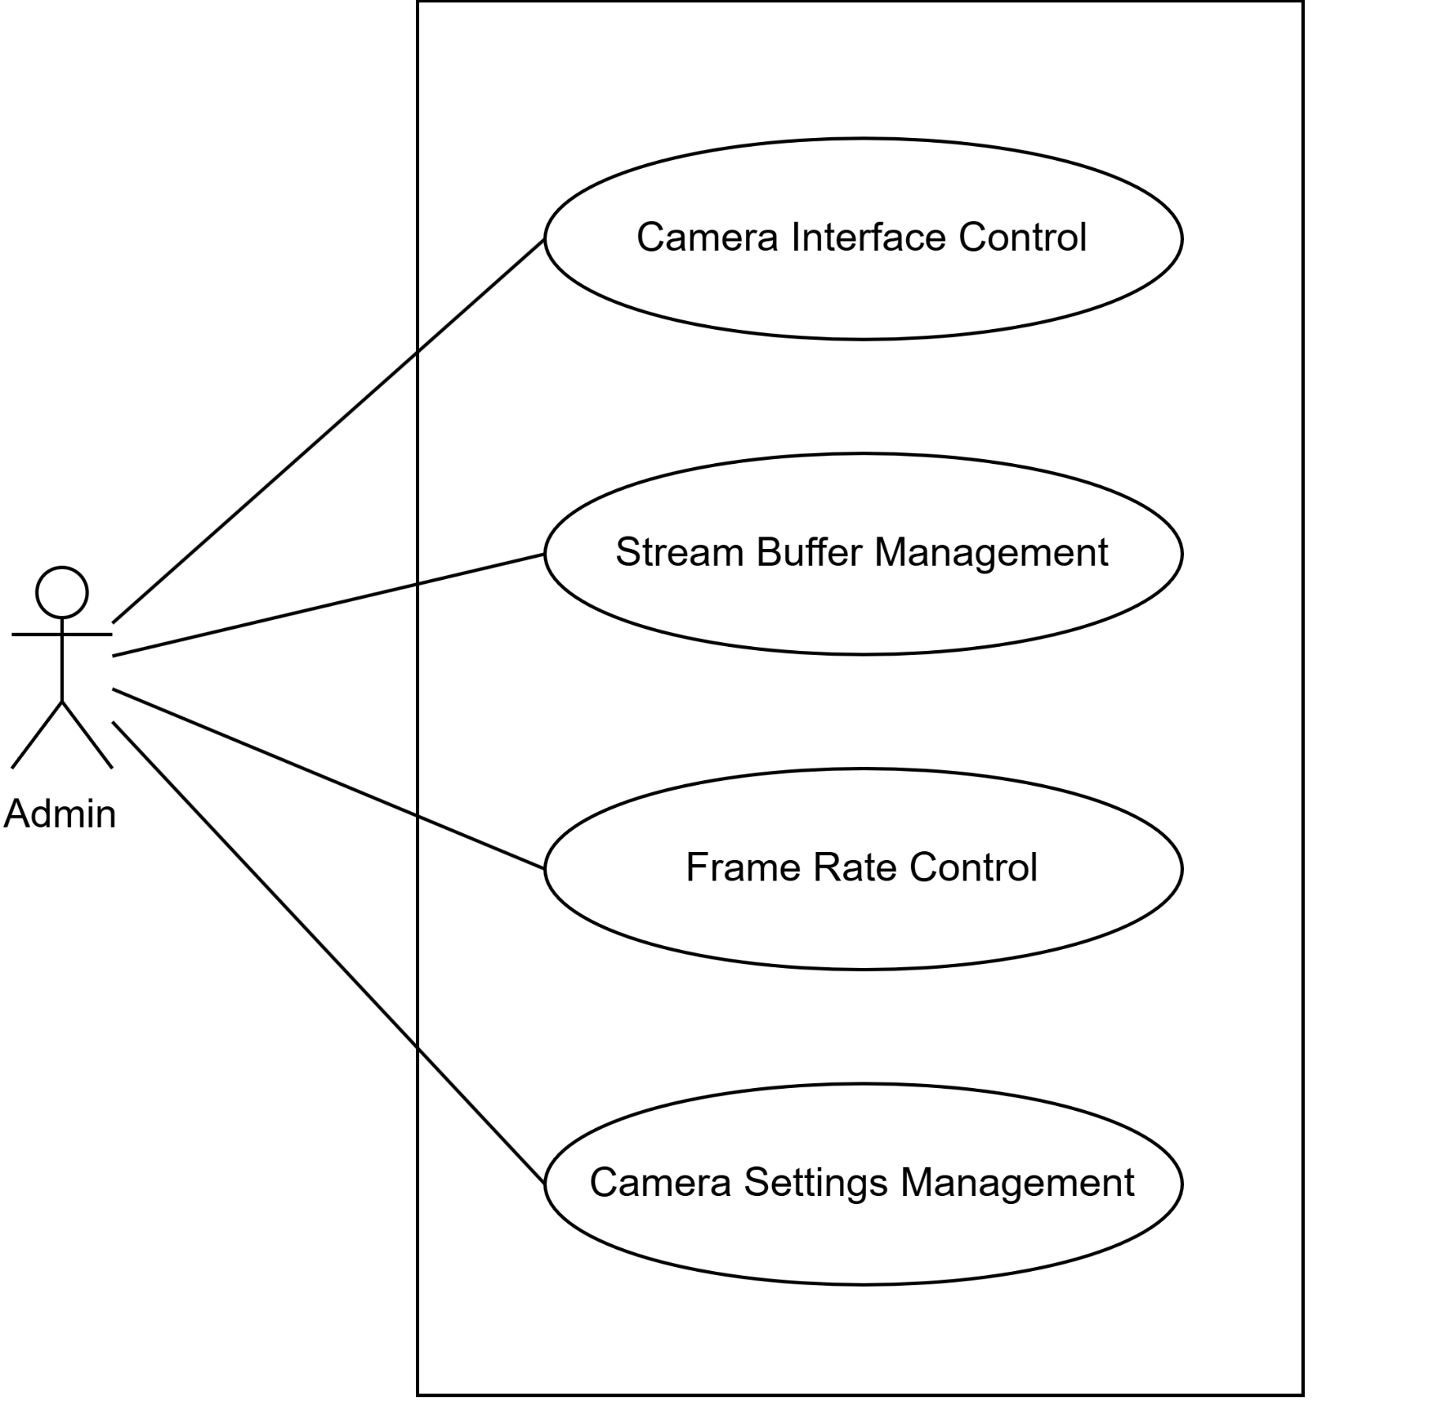
Name: Camera System

Figure 4: Use Case Diagram Level 1.1.5
Primary Actor: Admin
Use cases include:
- Camera Interface Control: Managing camera connections and interfaces
- Stream Buffer Management: Handling video stream buffering
- Frame Rate Control: Managing video frame rates
- Camera Settings Management: Configuring camera parameters

3.1.5 Level 1.2
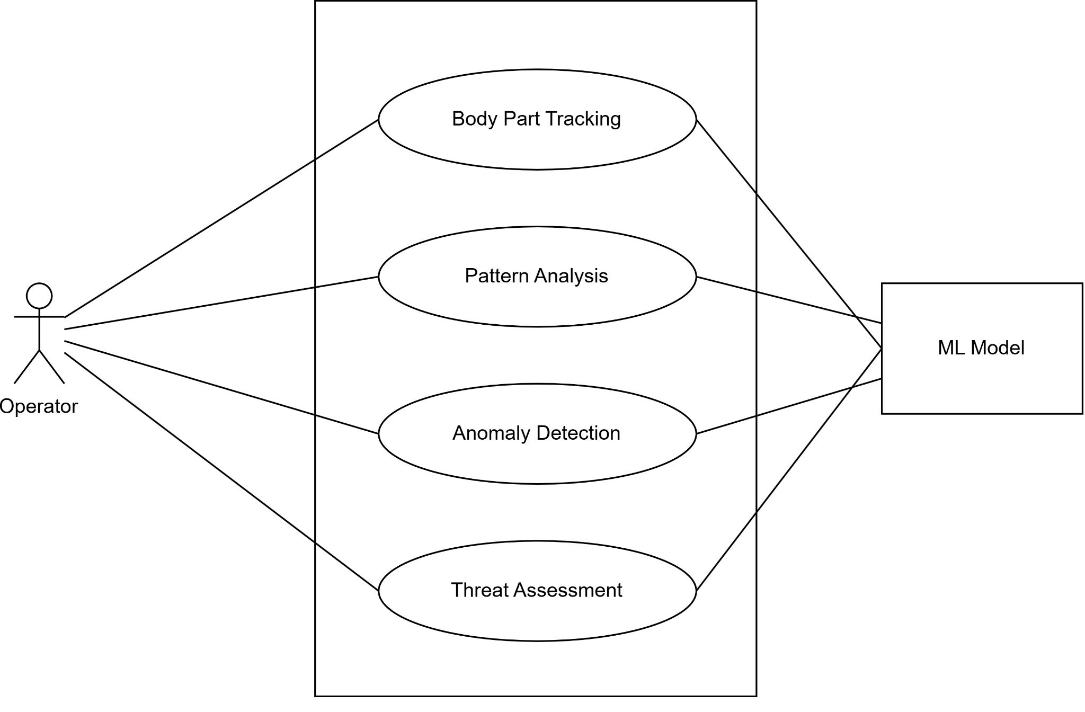
Name: Movement Detection

Figure 5: Use Case Diagram Level 1.2
Primary Actor: Operator
Secondary Actor: ML Model
Use cases include:
- Body Part Tracking: Tracking human body parts and movements
- Pattern Analysis: Analyzing movement patterns
- Anomaly Detection: Identifying unusual movements
- Threat Assessment: Evaluating potential security threats

3.1.6 Level 1.3
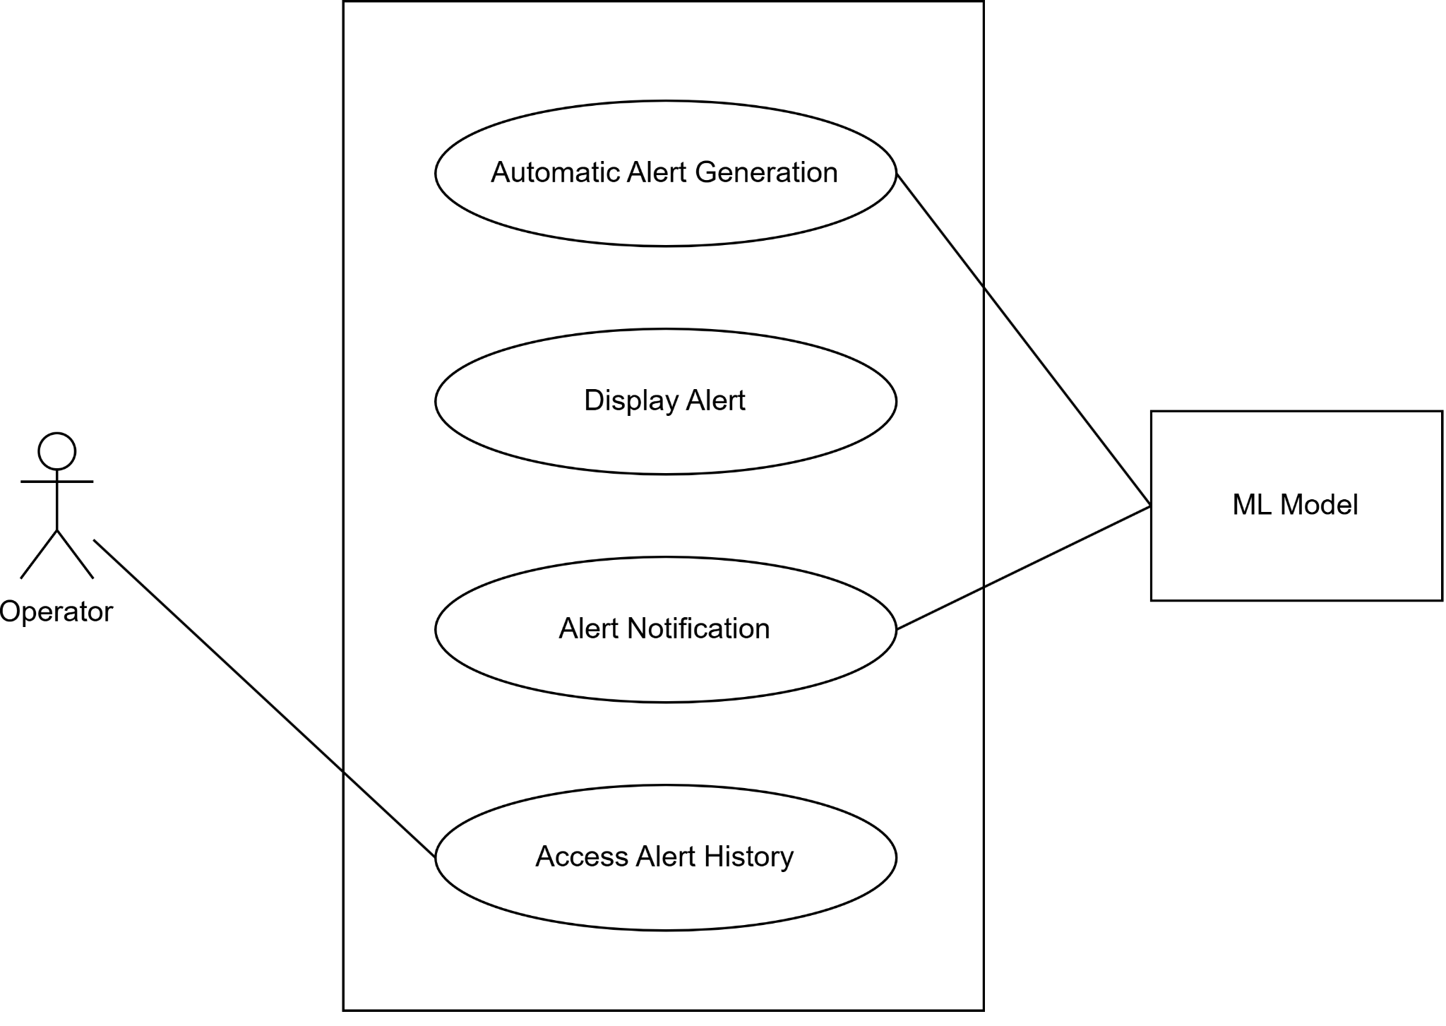
Name: Alert Management

Figure 6: Use Case Diagram Level 1.3
Primary Actor: Operator
Secondary Actor: ML Model
Use cases include:
- Automatic Alert Generation: Creating alerts based on detections
- Display Alert: Showing alerts in the interface
- Alert Notification: Sending notifications to operators
- Access Alert History: Reviewing past alerts

3.1.7 Level 1.4
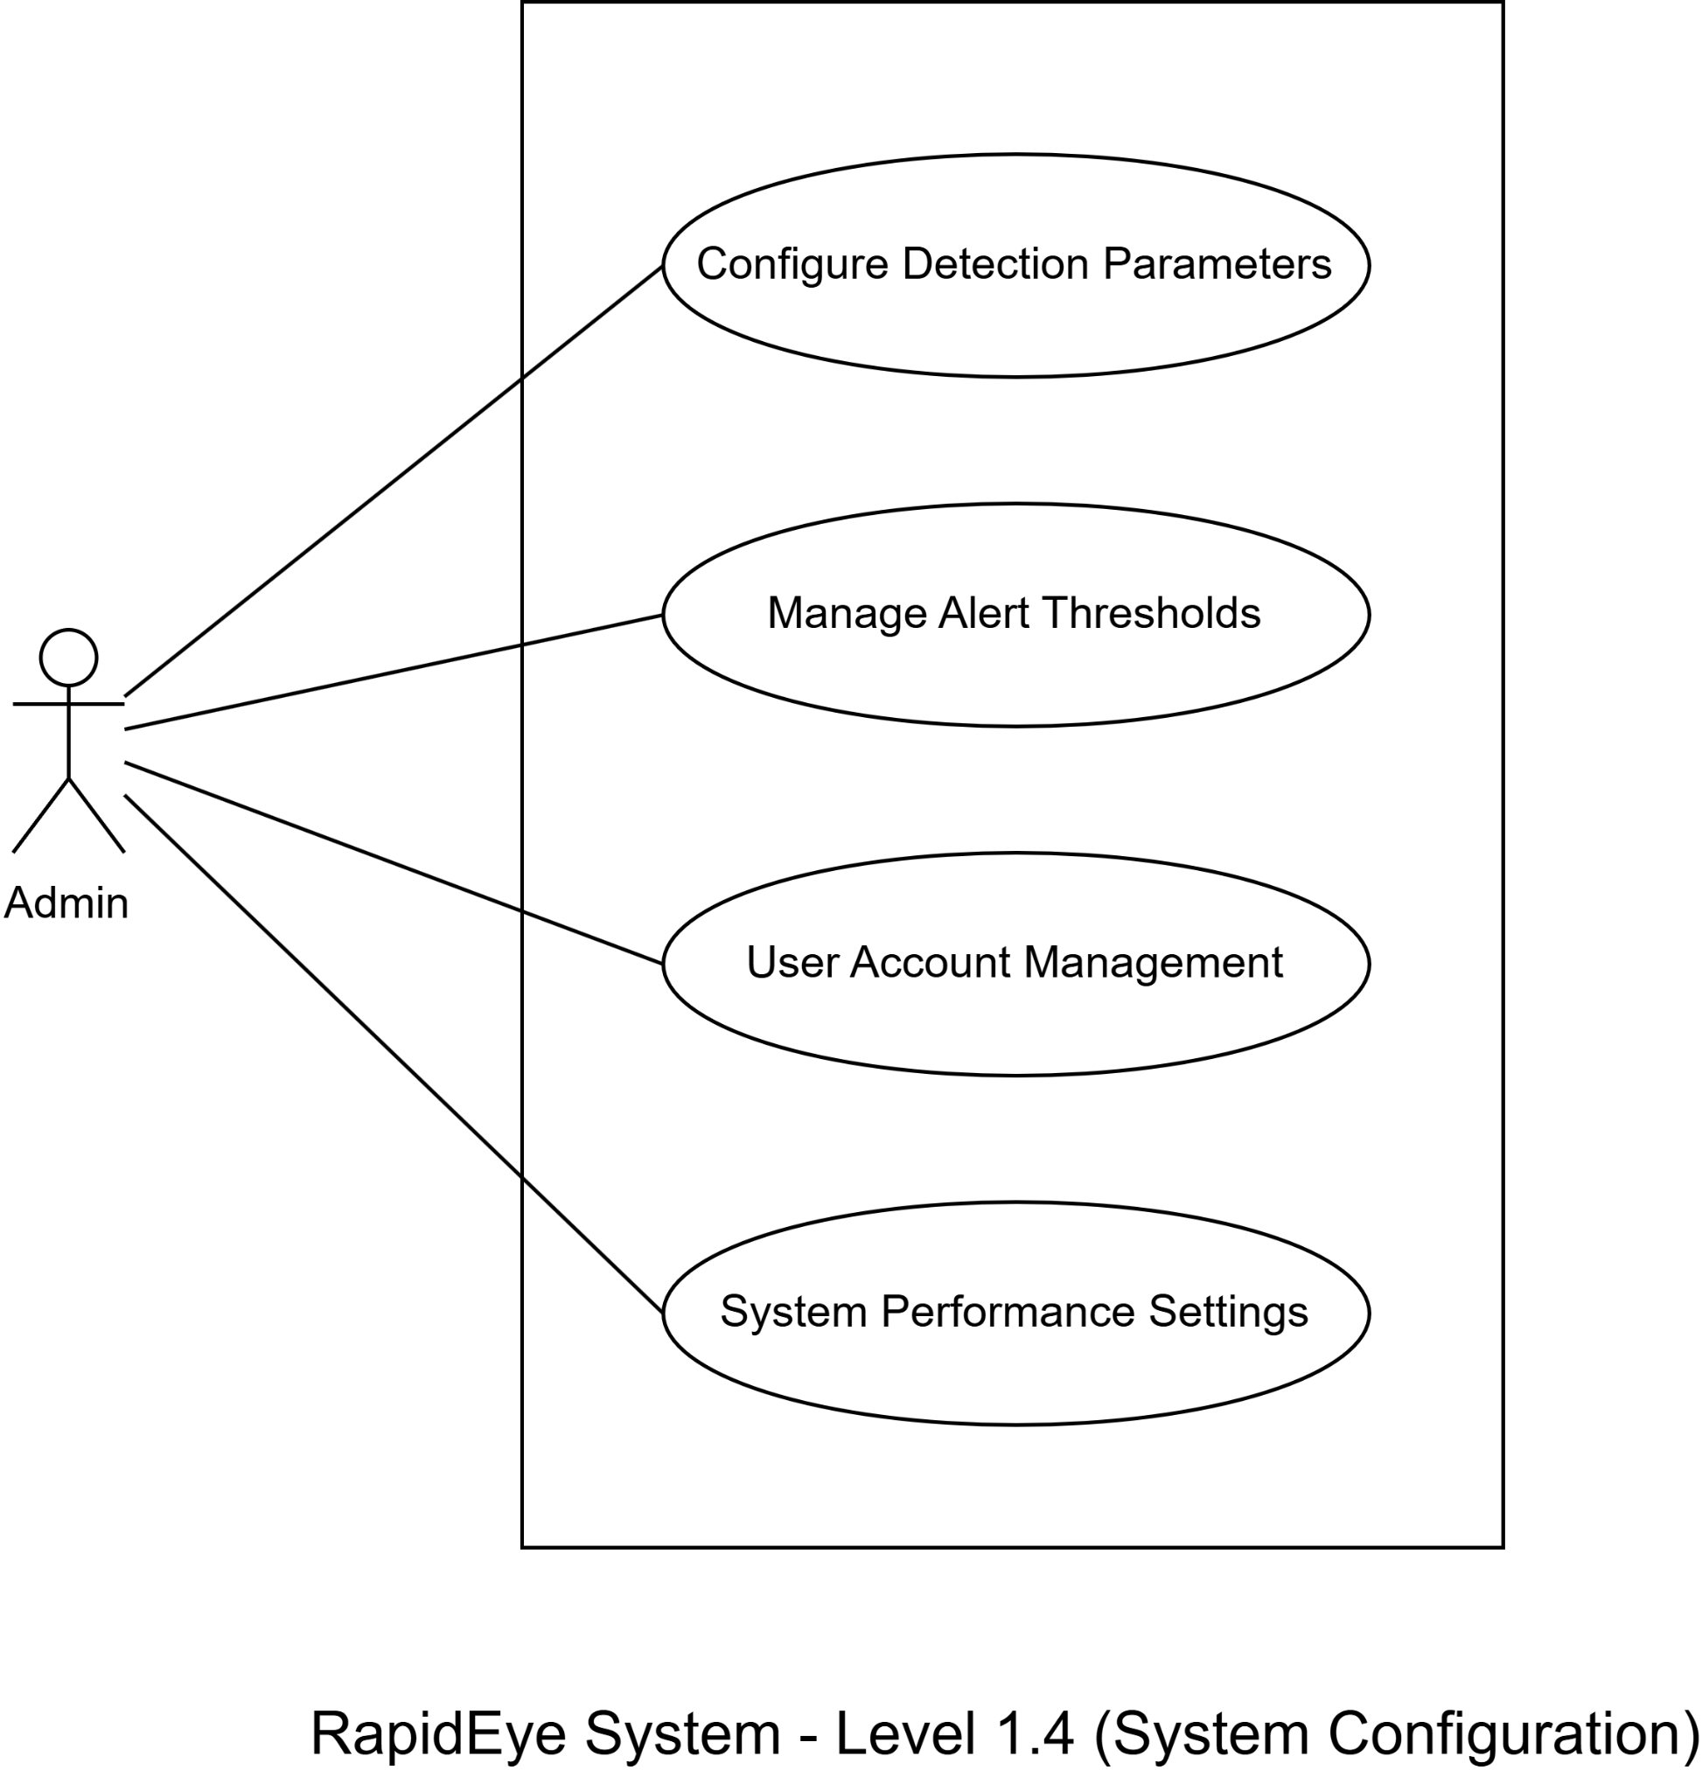
Name: System Configuration

Figure 7: Use Case Diagram Level 1.4

Primary Actor: Admin
Use cases include:
- Configure Detection Parameters: Setting up detection sensitivity and criteria
- Manage Alert Thresholds: Configuring alert triggering conditions
- User Account Management: Managing system users and permissions
- System Performance Settings: Optimizing system performance parameters

5. Class Based Modeling
Class-based modeling establishes the static structure of objects within a system, defining the overall framework of the system. A class model specifies the attributes and methods of objects in each class and outlines their interactions and collaborations across different classes. This modeling approach comprises several key components, including classes and objects, attributes, methods, class-responsibility-collaborator (CRC) models, collaboration diagrams, and packages.

5.1 Final List of Classes
First, I identified classes from the solution domain using general classifications such as system components, management units, and processing elements. Through analysis and refinement based on criteria like retained information, required services, multiple attributes, and essential requirements, I identified the following analysis classes:
- Video
- Movement
- Alert
- Zone
- Operator
- Settings

5.2 Class Card

5.2.1 Video

Class Name: Video
Attributes | Methods
-SourceID  -streamType (live/stored)  -frames  -recordingPath  -timestamp | +startStream()  +stopStream()  +recordVideo()  +playbackVideo()  +extractFrames()
Responsibilities | Collaborator Class
- Managers video input stream  - Handles frame processing  - Controls Recording and Playback  - Provides frame access for analysis | - Movement  - Zone

5.2.2 Movement

Class Name: Movement
Attributes | Methods
-trackingID  -personCount  -movementSpeed  -patternType  -detectionTime | +detectPerson()  +trackMovement()  +analyzeBehaviour()  +calculateSpeed()  +validatePattern()
Responsibilities | Collaborator Class
- Track and identify human presence  - Calculate movement speeds and patterns  - Identify suspicious behaviour  - Process multiple simultaneous tracks | - Video  - Zone  - Alert

5.2.3 Alert

Class Name: Alert
Attributes | Methods
-alertID  -alertType  -severity  -status  -timestamp  -description | +generateAlert()  +updateStatus()  +notifyOperator()  +logAlert()  +retrieveAlertHistory()
Responsibilities | Collaborator Class
- Generate Alerts for suspicious activities  - Manage Alert Lifecycle  - Maintain Alert History  - Notify Relevant Operators | - Movement  - Zone  - Operator

5.2.4 Zone

Class Name: Zone
Attributes | Methods
-zoneID  -boundaries  -sensitivity  -activeStatus  -alertThreshold  -description | +defineZone()  +updateBoundaries()  +setSensitivity()  +validateActivity()  +getZoneStatus()
Responsibilities | Collaborator Class
- Define monitoring areas  - Manage Zone Parameters  - Track zone specific activities  - Control detection sensitivity | - Movement  - Video  - Alert

5.2.5 Operator

Class Name: Operator
Attributes | Methods
-operatorID  -accessLevel  -status  -astLogin  -currentSession | +login()  +handleAlert()  +modifySettings()  +generateReport()  +manageZones()
Responsibilities | Collaborator Class
- Monitor System Activities  - Respond to alerts  - Manage system configurations  - Control access permissions | - Alert  - Zone  - Settings

5.2.6 Settings
Class Name: Settings
Attributes | Methods
-configID  -detectionParams  -alertThresholds  -systemPreferences  -performanceMetrics | +updateConfig()  +loadDefaults()  +validateSettings()  +applyChanges()  +backupConfig()
Responsibilities | Collaborator Class
- Manage System Configurations  - Control Detection Parameters  - Handle performance settings  - Maintain System preferences | - Operator  - Zone  - Alert

So based on the class cards, we can create the following table to summarise it:
Class Name | Collaborator Class
Video | Movement, Zone
Movement | Video, Alert, Zone
Alert | Movement, Zone, Operator
Zone | Video, Movement, Alert
Operator | Alert, Zone, Settings
Settings | Operator, Zone, Alert
The CRC Diagram is given below.

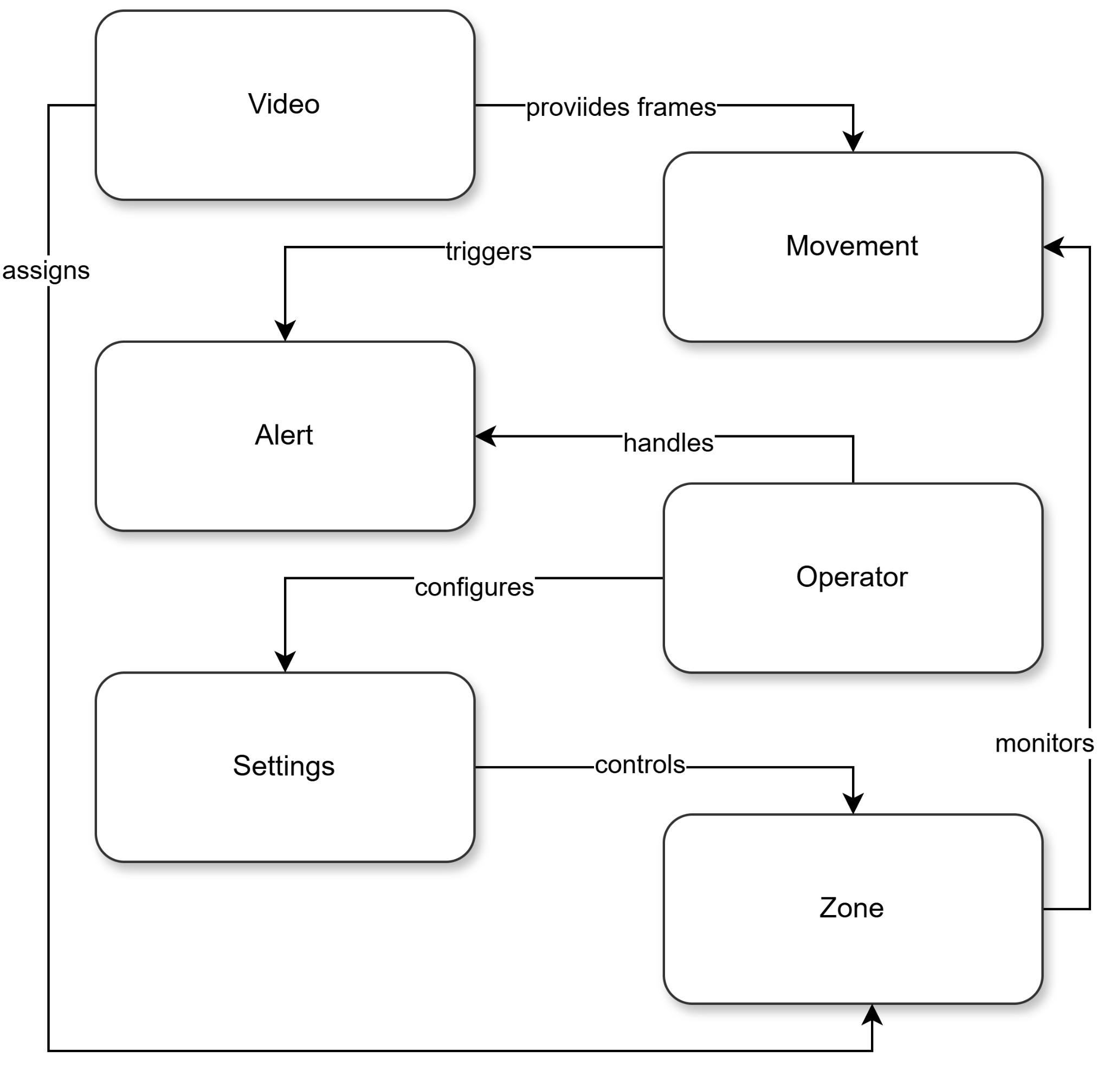

Figure 8: CRC Diagram

6. Software Design Architecture
When starting architectural design, it is essential to place the software in context by identifying the external entities it interacts with and the nature of those interactions. This information is typically derived from the requirements model and other data gathered during requirements engineering. Architectural design outlines the structure of the data and program components needed to develop a computer-based system. The process involves four key steps.

6.1 Architectural Context Diagram
At the architectural design level, an architectural context diagram models how software interacts with external entities that communicate with the target system using interfaces.
Superordinate systems:
- Video Management System
Subordinate systems:
- Movement Detection Engine
- Pose Estimation Service
- Pattern Recognition Service
Peer-level systems:
- None for our system
Actors:
- Security Operators
- System Administrators

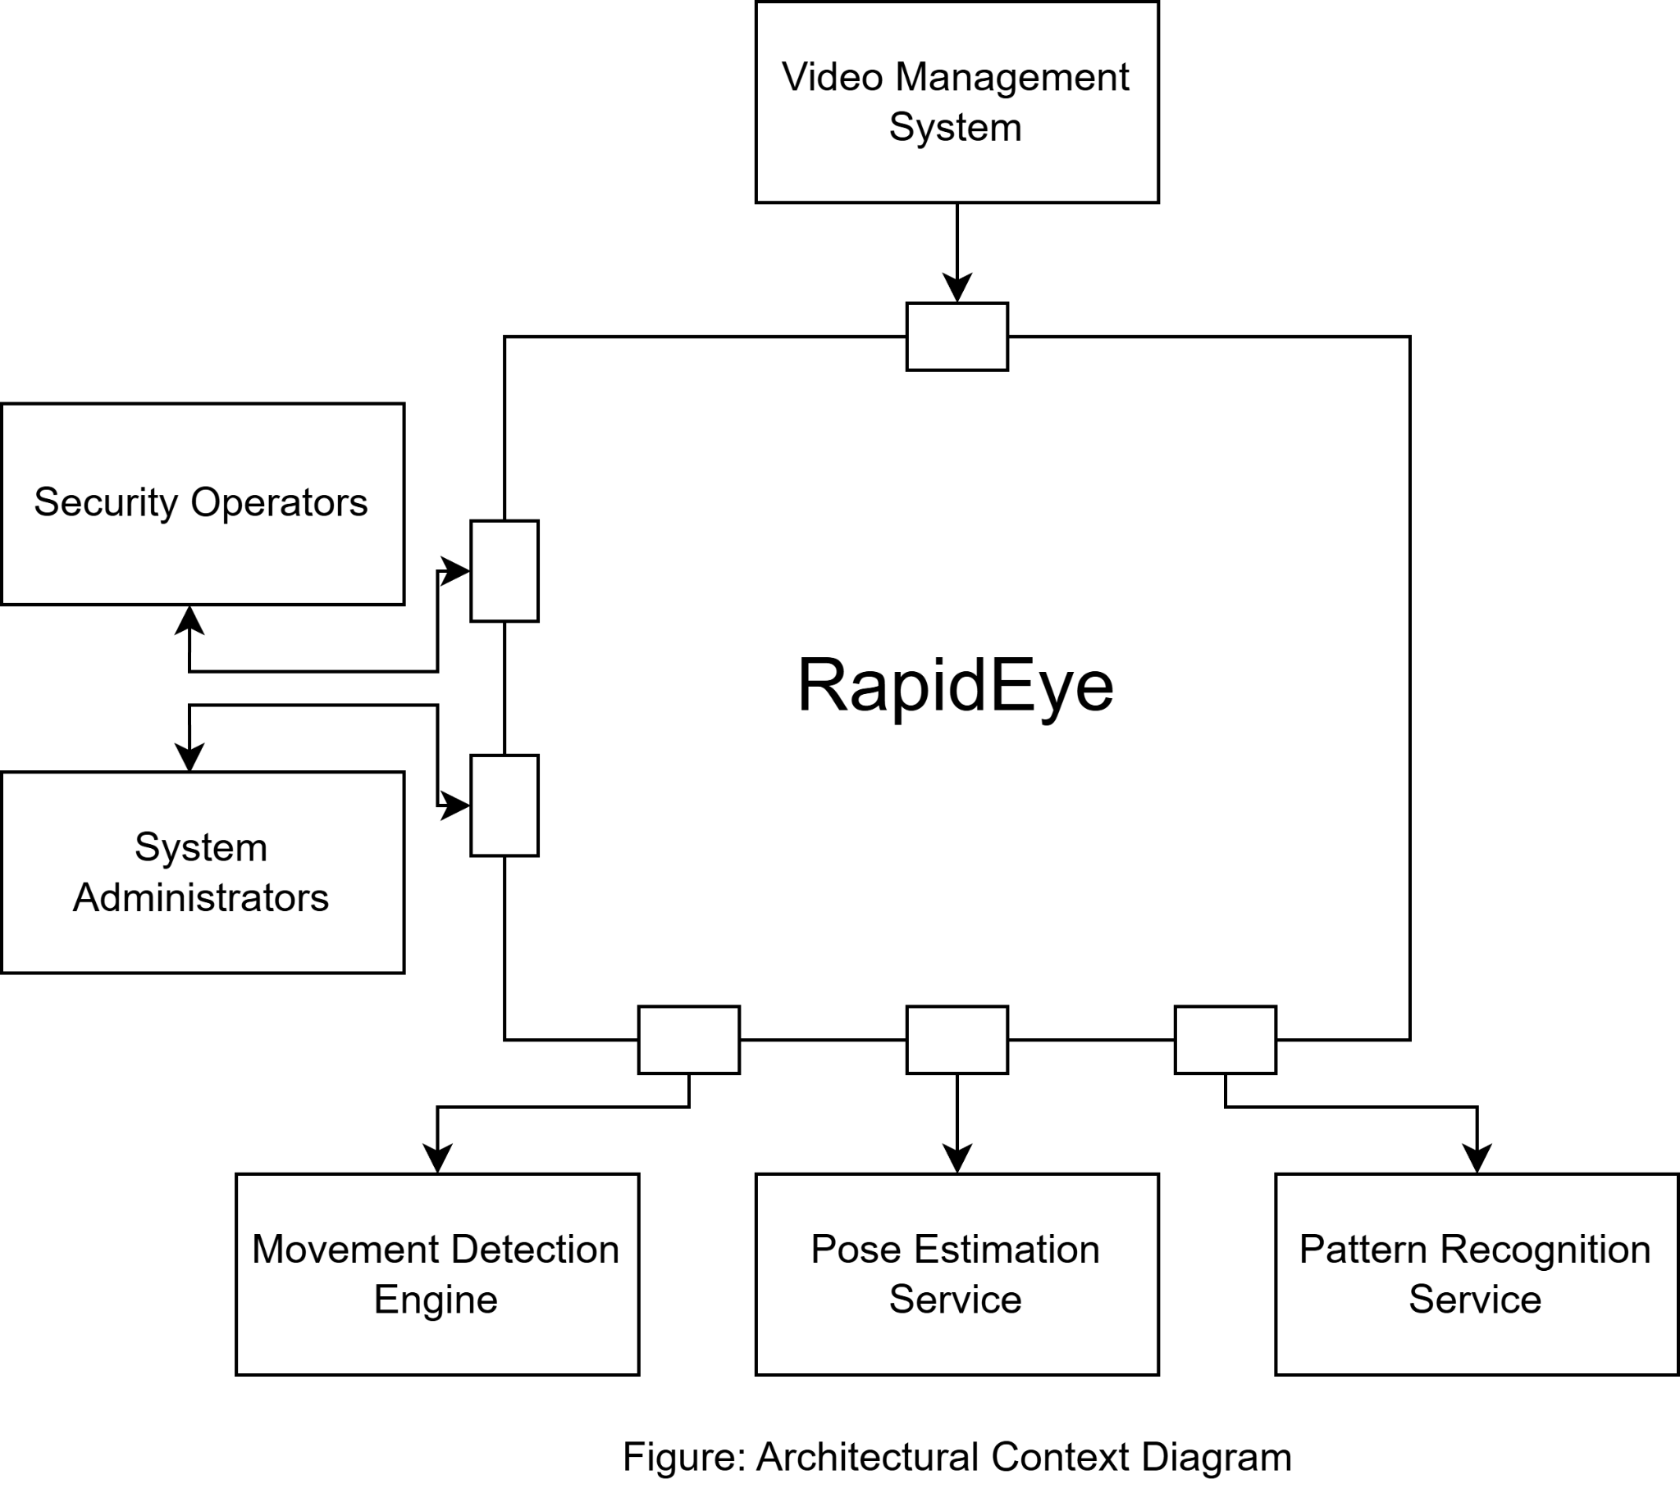
Figure 9: Architectural Context Diagram

6.2 Defining Archetypes
Our system employs three main architectural patterns that work together to create a robust surveillance system.

6.2.1 Pipe and Filter Architecture

Figure 10: Pipe and Filter Pattern for Video Processing
Sequential processing of video data through specialized components:
- Video Source → Frame Extraction → Movement Detection → Pattern Analysis
- Each component performs a specific transformation on the data
- Components are connected through data streams

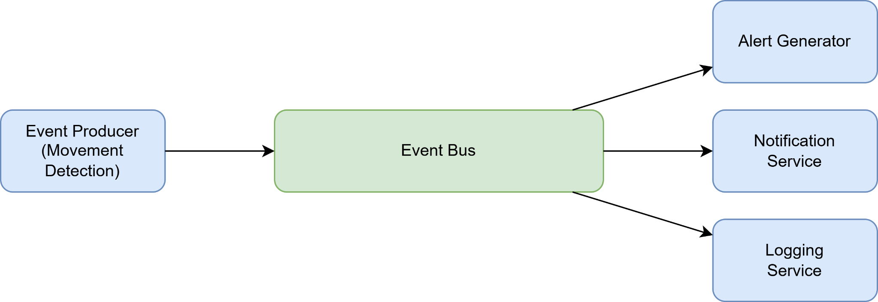
6.2.2 Event Driven Architecture

Figure 11: Event-Driven Architecture for Alert Management
An event-driven approach for handling detected events and alerts:
- Event Producer generates movement detection events
- Central Event Bus routes events to appropriate handlers
- Multiple consumers (Alert Generator, Notification Service, Logging Service) process events independently

6.2.3 Layered Architecture
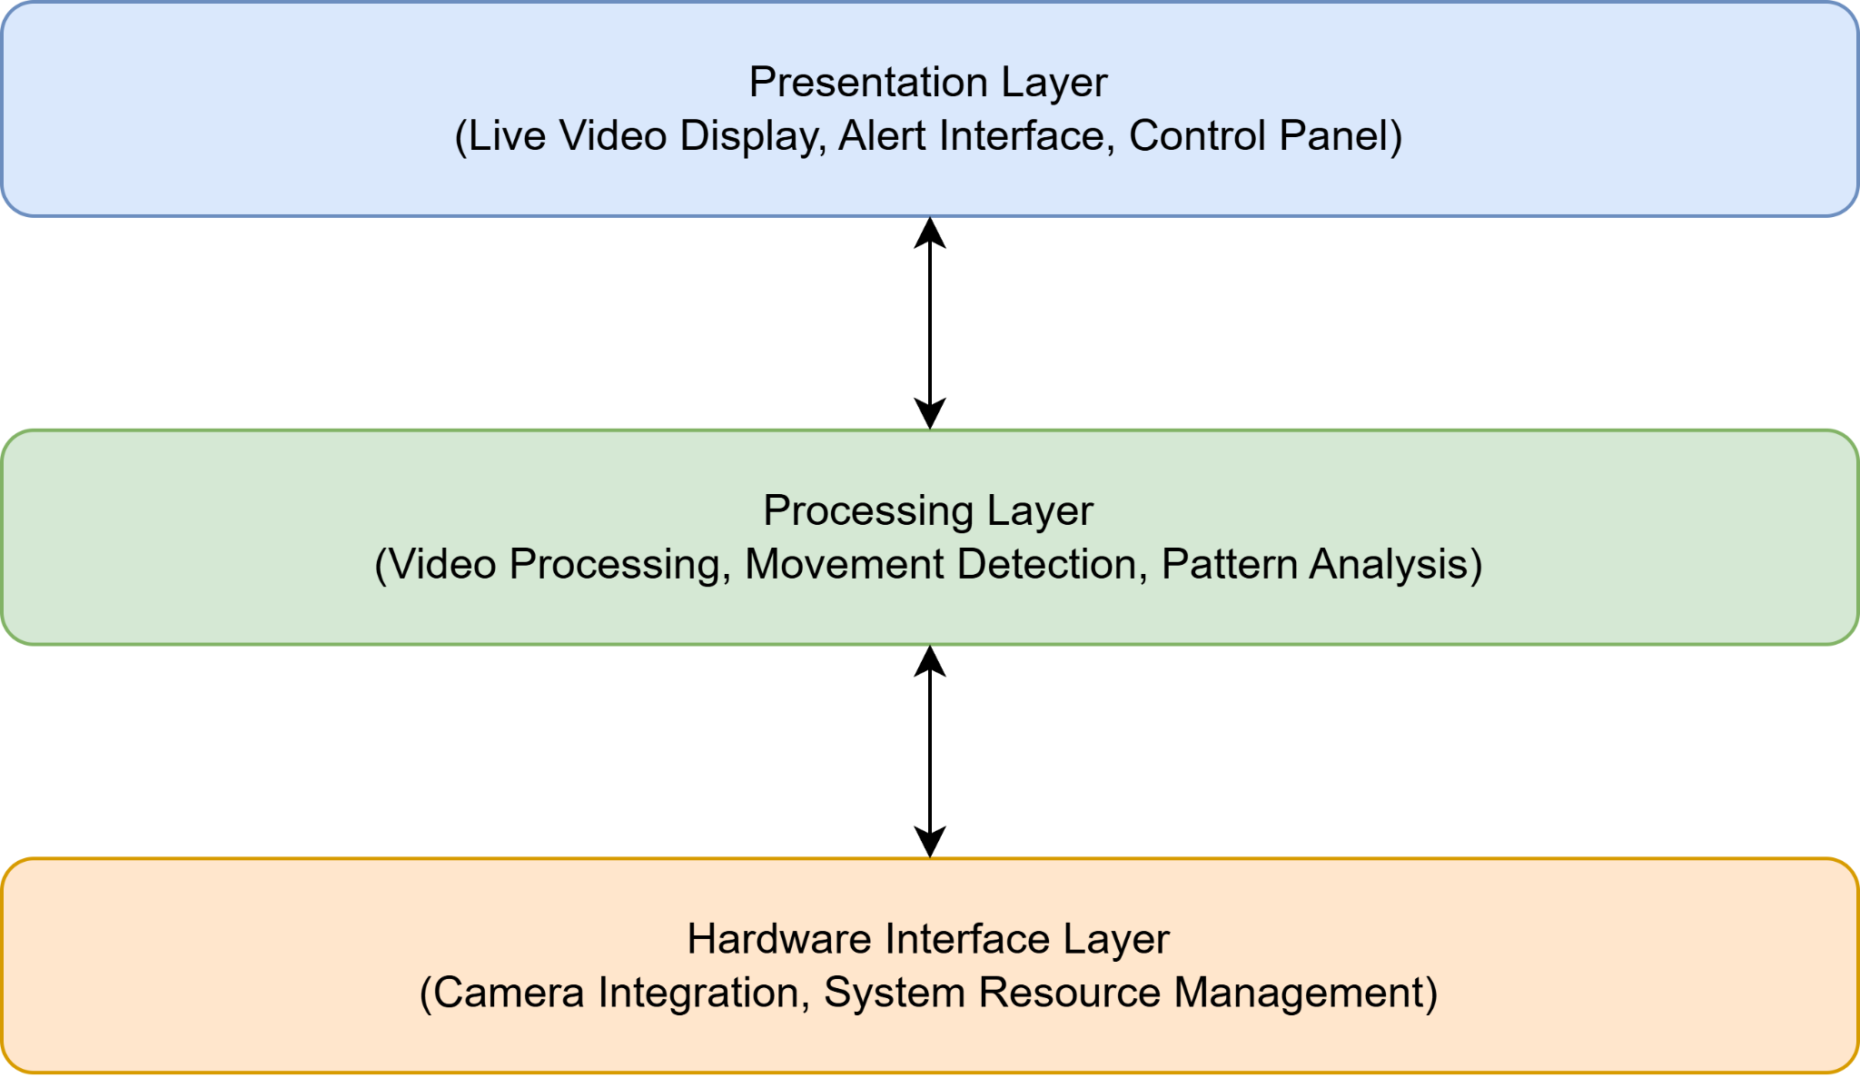

Figure 12: Layered Architecture

This pattern divides the system into three distinct layers:
- Presentation Layer: Handles user interaction through video display, alerts, and control interfaces
- Processing Layer: Manages core functionality including video processing and detection algorithms
- Hardware Interface Layer: Manages system resources and camera integration

6.3 Refining the Architecture into components

6.3.1 Top level Components
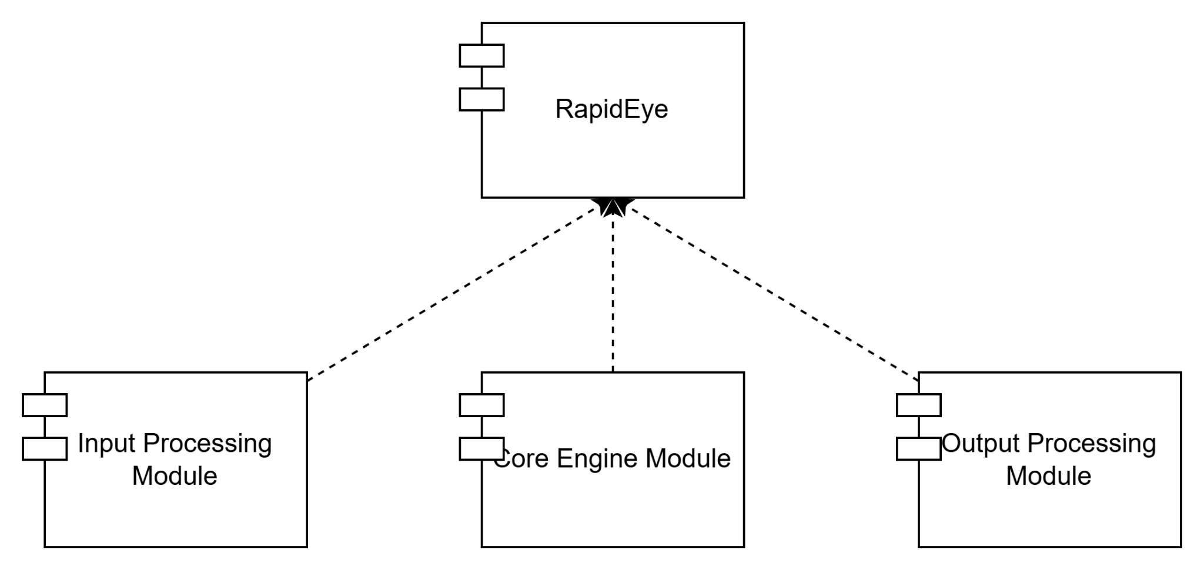
Top level components have been illustrated below. Top level components give us a very high level view of the system, and requires further refinement, which is done in subsequent steps. We limit the top level components to 2 layers because our system is inherently not very complicated, as well as facilitating understanding of the system from a top-down perspective.

Figure 13: Top Level Components

6.3.2 Instantiation
The components identified at the Top Level are broad and require further refinement into smaller, more detailed components. However, simply assembling a collection of components does not result in a coherent design. To create a maintainable and effective system, architecture is applied to these components. This ensures the structure and components are tailored to address a specific problem, demonstrating their suitability and effectiveness.
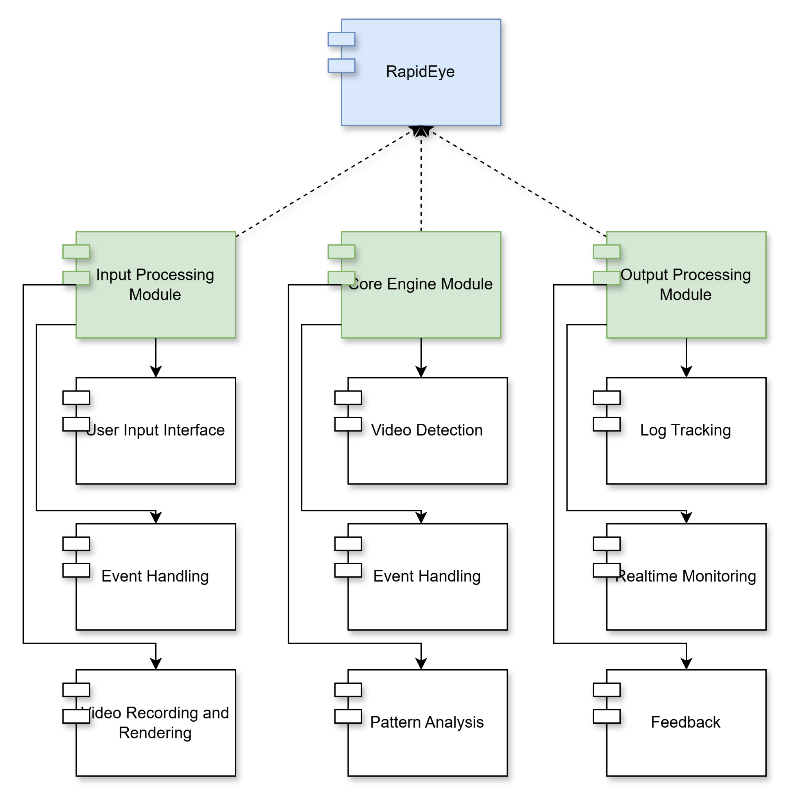

Figure 14: Instantiation of components to second level

6.4 Mapping Requirements to Software Architecture

Functional Requirement | Mapped Component(s)
Video Processing: Real-time and stored video analysis | Processing System (Input Interface, Video Recording and Rendering, Event Handling)
Movement Detection: Track and analyze human movements | Video Analysis & AI (Video Detection, Movement Analysis, Pattern Analysis)
Multiple Person Tracking: Track multiple individuals simultaneously | Video Analysis & AI (Movement Analysis, Pattern Analysis)
Alert Generation: Generate real-time alerts for suspicious movements | Monitoring and Tracking (Real-Time Monitoring, Feedback Analysis)
Performance Optimization: Efficient CPU hardware operation | Cross-cutting across all components with hardware resource management
Event Recording: Automatic recording of detected events | Processing System (Video Recording) + Monitoring and Tracking (Tracking by Logs)
Interaction Analysis: Detect and assess potential threats from interactions | Video Analysis and AI (Pattern Analysis) + Monitoring and Tracking (Tracking by Logs)

7. Test Plan

7.1 High-Level Testing Goals
Testing goals from a high level can be classified as the following:
1. Validate Video Processing Accuracy
- Verify frame extraction and processing
- Test movement detection precision
- Validate pattern recognition accuracy

2. Verify Alert System Functionality
- Test alert generation timing
- Validate notification delivery
- Verify alert classification accuracy

3. Evaluate System Performance
- Test multi-camera processing capability
- Measure system response times
- Validate resource utilization

4. Assess Integration Points
- Test camera interface compatibility
- Verify external system communications
- Validate data storage and retrieval

7.2 Test Cases

TC01: Video Input Processing
Objective: Verify video stream handling
Pre-conditions: System running, camera connected
Test Steps:
1. Connect multiple video sources
2. Verify frame capture rate
3. Check video quality retention
4. Validate multi-stream processing
Expected Results: Smooth video processing without frame drops

TC02: Movement Detection
Objective: Validate movement detection accuracy
Pre-conditions: Video input active
Test Steps:
1. Simulate various movement patterns
2. Test detection in different lighting
3. Verify detection zones functionality
4. Measure false positive rate
Expected Results: >75% detection accuracy with <25% false positives

TC03: Alert Generation
Objective: Test alert system functionality
Pre-conditions: Movement detection active
Test Steps:
1. Trigger various alert conditions
2. Verify alert classification
3. Check notification delivery
4. Validate alert history recording
Expected Results: Real-time alert generation with correct classification

TC04: System Performance
Objective: Evaluate system under load
Pre-conditions: Multiple cameras active
Test Steps:
1. Process multiple video streams
2. Monitor CPU/memory usage
3. Test system responsiveness
4. Measure alert generation latency
Expected Results: Stable performance within resource limits

TC05: User Interface
Objective: Verify UI functionality
Pre-conditions:System operational
Test Steps:
1. Test all navigation paths
2. Verify display layouts
3. Check real-time updates
4. Validate user input handling
Expected Results: Responsive interface

TC06: Configuration Management
Objective: Test system configuration features
Pre-condition: Admin access available
Test Steps:
1. Modify detection parameters
2. Update camera settings
3. Configure alert rules
4. Test user management
Expected Results: Accurate application of all configurations

TC07: Integration Testing
Objective: Validate system integration points
Pre-conditions: All subsystems operational
Test Steps:
1. Test camera integration
2. Verify storage system
3. Check notification delivery
4. Validate external interfaces
**Expected Results:** Seamless interaction between components

TC08: Recovery Testing
Objective: Verify system recovery capabilities
Pre-conditions: System running normally
Test Steps:
1. Simulate power failure
2. Test network interruption
3. Check data recovery
4. Verify service restoration
Expected Results: Automatic recovery with data integrity

TC09: Security Testing
Objective: Validate system security
Pre-conditions: System fully configured
test Steps:
1. Test access controls
2. Verify data encryption
3. Check audit logging
4. Test intrusion detection
Expected Results: All security measures functioning properly

TC10: Long-Term Stability
Objective: Verify system stability over time
Pre-conditions: System in production environment
Test Steps:
1. Run continuous operation
2. Monitor resource usage
3. Check for memory leaks
4. Verify data management
Expected Results: Stable long-term operation

Conclusion
The RapidEye system combines real-time video surveillance with intelligent threat detection through a modular and scalable architecture. Through its three main components - Processing System, Video Analysis & AI, and Monitoring & Tracking - the system effectively handles video processing, movement detection, and alert generation.
The architectural patterns employed (layered, event-driven, and pipe-filter) ensure robust performance while maintaining flexibility for future enhancements. The comprehensive testing plan validates both functional requirements and system reliability.
Moving forward, RapidEye can be extended with additional AI capabilities and support for diverse camera systems, further strengthening its role in automated surveillance.

Project Report - RapidEye

8. Methodology
This chapter presents the comprehensive approach and methodological framework employed in developing RapidEye, an innovative video monitoring system that leverages deep learning techniques for abnormal and rapid event detection.

8.1 Core Components
RapidEye operates through three primary interconnected modules that work in harmony to provide accurate event detection capabilities. Each module has been carefully designed to handle specific aspects of the detection process while maintaining seamless integration with other components.

8.1.1 Video Processing Module
The Video Processing Module serves as the foundation of RapidEye's analytical capabilities. At its core, this module employs a sophisticated frame processing engine that automatically handles both real-time and pre-recorded video feeds. The system processes incoming video streams through multiple stages: frame acquisition, pre-processing, and sequence building. Each frame undergoes careful normalization and resizing to ensure consistent input for the analysis pipeline. The module implements efficient frame buffering techniques to maintain real-time processing capabilities while ensuring no significant events are missed.

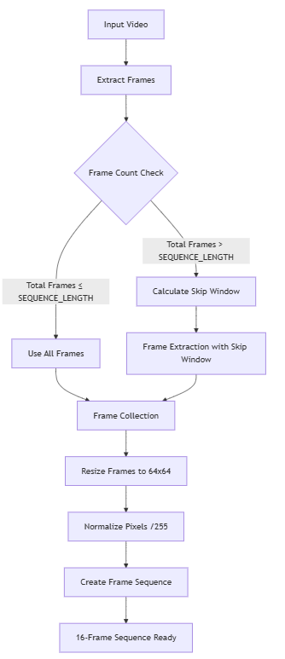

Figure 15: Video Processing Pipeline

8.1.2 Motion Analysis Module
The Motion Analysis Module represents the analytical core of RapidEye, enabling the system to detect and analyze movement patterns within video streams. The module begins with advanced background subtraction techniques that effectively isolate moving objects from static backgrounds. It employs sophisticated contour detection algorithms that identify and track motion regions. The system maintains high accuracy across different environmental conditions through careful calibration of motion sensitivity thresholds and region merging algorithms.
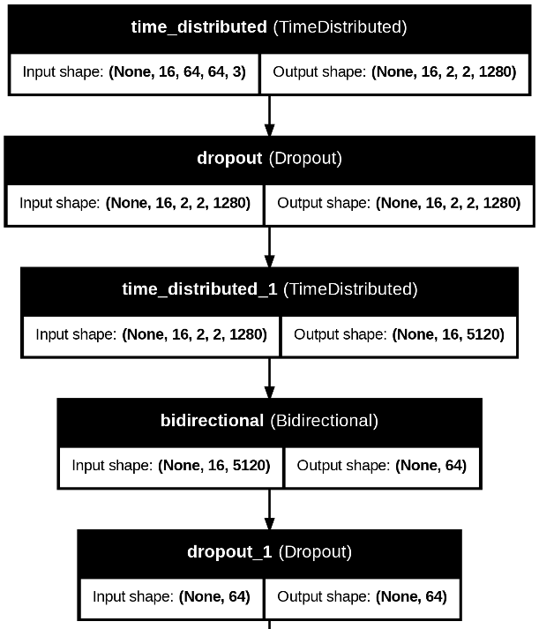

Figure 16: Motion analysis

8.1.3 Event Detection Module
The Event Detection Module synthesizes the outputs from the previous modules to provide actionable detection results. Through advanced pattern recognition techniques integrated with our deep learning model, the module analyzes motion patterns against learned characteristics of abnormal events. The processing pipeline incorporates:
- Sequence-based analysis of frame patterns
- Real-time speed and movement assessment
- Multi-object tracking and interaction analysis
- Automated alert generation for detected events

8.2 Implementation Process
The implementation of RapidEye follows a systematic process designed to ensure robust functionality and reliable results. The process begins with comprehensive data collection and preprocessing, where historical data from various scenarios is gathered and standardized. This forms the foundation for model development, where deep learning models are built, trained, and validated against test datasets.
The system integration phase brings together all components through well-defined API endpoints and a user-friendly interface. Extensive testing is conducted to verify system functionality and performance across different scenarios.

8.3 Quality Assurance Framework
RapidEye maintains high quality standards through a comprehensive quality assurance framework. This includes rigorous code quality processes with automated testing pipelines and thorough code review procedures. Model quality is ensured through regular validation and performance benchmarking, with metrics tracking both processing efficiency and detection accuracy.
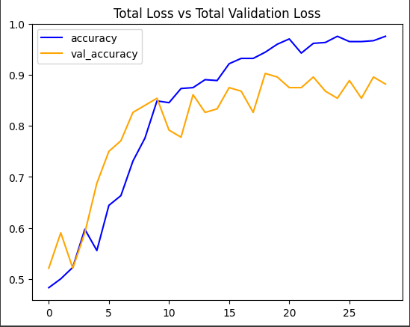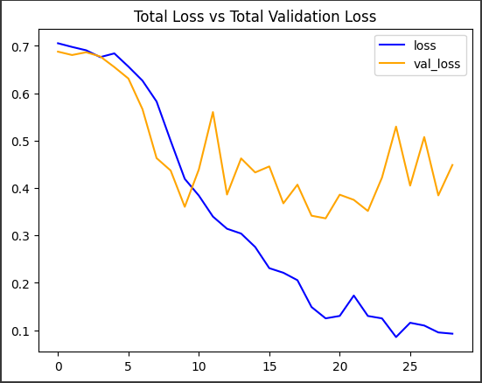

Figure 17: Validation improvements in Loss and Accuracy

9. User Interface

9.1 Landing Page
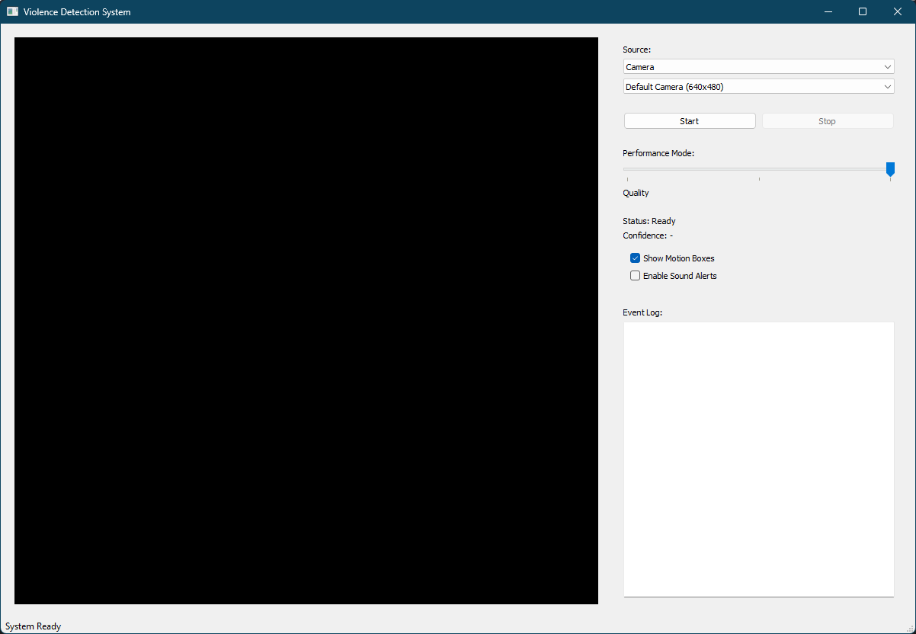

Figure 18: Landing Page

9.2 Sample Violence Detected
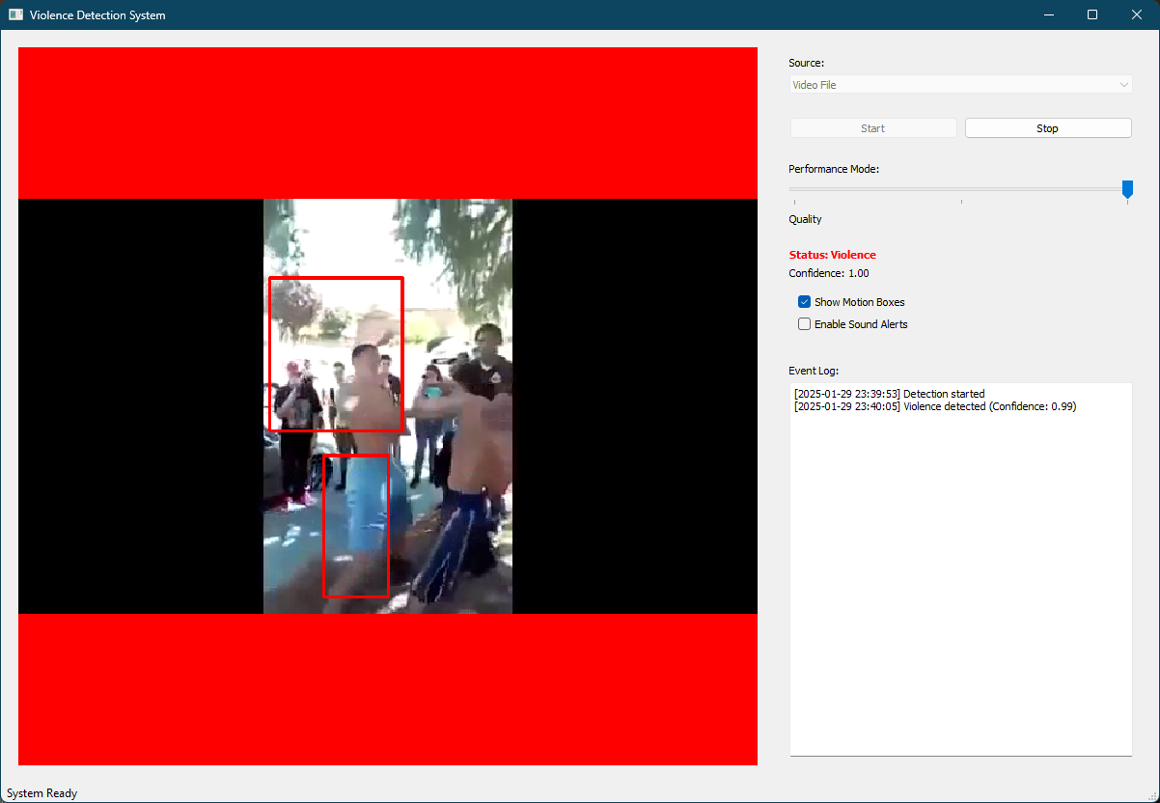

Figure 19: Sample of violence detected

9.3 List of Core Functionalities
- Video Source Management:
- Camera feed processing
- Video file processing
- Multiple camera support with dynamic switching
- Real-time frame processing and buffering
- Event Detection:
- Real-time movement detection using background subtraction
- Motion region tracking and analysis
- Frame sequence analysis for event detection
- Confidence score calculation
- Event classification (Violence/NonViolence)
- Alert System:
- Visual alerts during detected events (red border indicators)
- Sound alert capabilities during events
- Status display with confidence scores
- Event logging with timestamps
- Performance Management:
- Three performance modes (Performance, Balanced, Quality)
- Configurable frame processing settings
- Adjustable detection thresholds
- Playback speed control for video files
- System Configuration:
- Configurable camera selection
- Adjustable alert settings
- Performance mode selection
- Monitoring Interface:
- Real-time video display
- Motion region visualization
- Event status display

10. Implementation Details
This chapter presents the implementation specifics of RapidEye, detailing the technologies, architecture, and key components of the system.

10.1 Technologies Used

10.1.1 Frontend Technologies
- PyQt5 Framework: Used for building the desktop user interface
- Core Libraries and Tools:
  - OpenCV: For video processing and frame analysis
  - NumPy: For numerical computations and array operations
  - Qt Multimedia: For sound alert handling
  - Qt Core: For event handling and threading

10.1.2 Backend Technologies
- Python 3.12.4: Primary programming language for backend development
- Libraries and Tools:
  - TensorFlow: For deep learning model implementation
  - Joblib: For model serialization
  - OpenCV-Python: For video capture and processing

10.2 Component Implementation

10.2.1 Video Processing System
The video processing system is implemented through several specialized components:
- Frame Capture and Processing:
  - Handles multiple video sources (cameras and files)
  - Implements frame buffering and sequence management
  - Processes frames for model input

10.2.2 Event Detection System
The detection system consists of:
- Data Preprocessing:
  - Frame sequence buffering
  - Image normalization and resizing
  - Motion region extraction
- Deep Learning Model:
  - MobileNetV2 backbone for feature extraction
  - Bidirectional LSTM for temporal analysis
  - Binary classification output (Normal/Abnormal)
  - Training on a dataset of abnormal and normal events

10.2.3 Alert Generation System
- Real-time event monitoring
- Confidence threshold management
- Visual and audio alert triggers
- Event logging and persistence

10.3 Key Implementation Features

10.3.1 Performance Optimization
- Thread-based processing for UI responsiveness
- Efficient memory management for video streams

10.3.2 Error Handling and Recovery
- Robust video source management
- Automatic recovery from connection losses
- Graceful degradation under resource constraints
- Comprehensive error logging

10.4 Code Organization
rapideyeapp/
├── core/
│ ├── model_service.py
│ ├── video_service.py
│ └── motion_detector.py
├── utils/
│ ├── config.py
│ └── sound.py
└── ui/
│ ├── main_window.py

11. User Manual

11.1 Installation
Option 1: Git Installation
- Open terminal in any directory and Clone the repository:
git clone https://github.com/nosferatu0205/violence-detection-system
cd violence-detection-system
- Create and activate venv
python -m venv venv
# For Windows
venv\Scripts\activate
# For Linux/Mac
source venv/bin/activate
- Install dependencies
pip install -r requirements.txt
Run using ./run.sh.

11.2 System Requirements
- Operating System: Windows 10/11, macOS, or Linux
- Python 3.8 or higher (for source installation)
- Webcam or video files for input
- Minimum 4GB RAM
- GPU recommended but not required

11.3 Getting Started
- Launch the application:
  - From source: Run python main.py
  - From executable: Double click RapidEye.exe
- Configure Video Source:
  - Select video source (Camera/Video File)
  - If using camera, select from available devices
  - If using video file, browse and select file
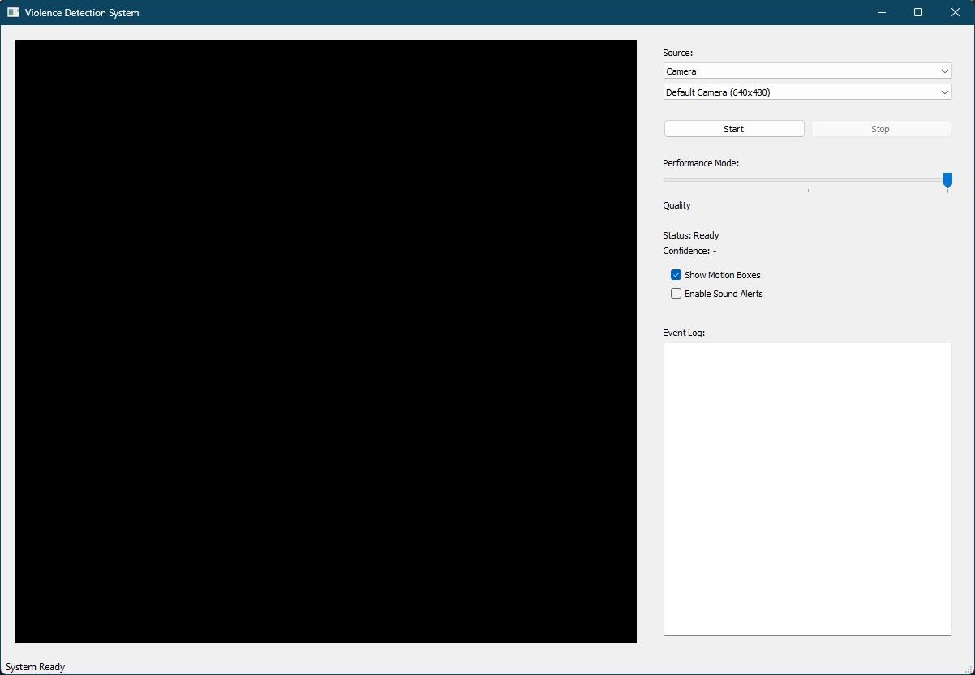

Figure 20: Initial Configuration Screen

11.4 Using RapidEye
- Performance Mode Selection:
  - Choose between Performance, or Quality modes
  - Performance: Optimized for faster processing, lower resource usage
  - Quality: Maximum accuracy, higher resource usage
- Alert Settings:
  - Configure sound alerts (Enable/Disable)
  - Set motion detection sensitivity
  - Enable/Disable motion region boxes
- Starting Detection:
  - Click "Start" to begin monitoring
  - The system will automatically:
    - Process video frames
    - Detect motion regions
    - Analyze for abnormal events
    - Generate alerts when events detected
- During Detection:
  - Main window shows live video feed
  - Motion regions highlighted in green (normal) or red (abnormal)
  - Status panel shows current state and confidence level
  - Event log records all detected events with timestamps
- Event Review:
  - Each entry includes timestamp and confidence level
- Stopping Detection:
  - Click "Stop" to end monitoring
  - Return to source selection state

Conclusion
In this report, I have thoroughly discussed the technical details necessary to develop "RapidEye: Smart Video Monitoring and Alert System for Abnormal and High-Speed Events". The documentation provides a comprehensive overview of the system's architecture, encompassing scenario-based modeling, class-based modeling, and detailed architectural design.
The system successfully implements its core functionalities through a sophisticated pipeline that includes:
- Real-time video processing and frame analysis
- Advanced motion detection using background subtraction
- Deep learning-based event classification using MobileNetV2 with BiLSTM
- Multi-threaded processing for responsive performance
- Configurable alert generation system
RapidEye demonstrates several technical achievements:
- Efficient frame sequence processing while maintaining real-time performance
- Adaptive performance modes to accommodate different hardware capabilities
- Robust error handling and recovery mechanisms
- Comprehensive logging and event tracking capabilities
While RapidEye effectively addresses automated abnormal event detection, there are several potential areas for future enhancement:
- Support for additional video formats and sources
- Integration with cloud-based storage for event archival
- Enhanced analytics and reporting features
- Extended machine learning model capabilities for specific event types
- Multi-camera synchronization and correlation
Through this document, I have strived to present a clear and thorough understanding of the system's workflow and technical implementation, supported by illustrative figures and tables. I hope this report proves valuable for understanding RapidEye's role in advancing automated video monitoring and event detection technology.

